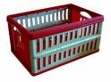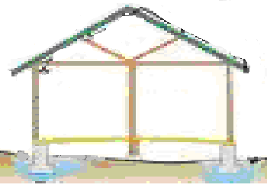 | 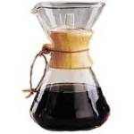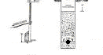
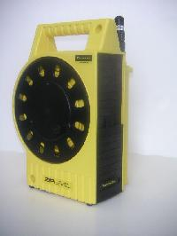  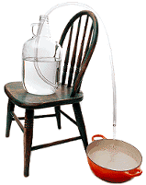 | 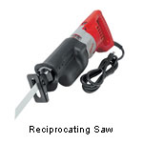
Foundation
What is the foundation?
The concrete? Or the ground below it?
Drainage
Where does water really go?
Depth, depth, depth
Settlement
How much is too much?
How do I monitor it? Should I fix it?
Water Intrusion
How do you find that leak?
Destructive testing or technology options?

